MAINTENANCE VISIT – GOVT. PRIMARY SCHOOL, SEMBAKKAM (THIRUPORUR, CHENNAI)
The NSS unit of SSN successfully organized a Maintenance Visit to the Government Primary School at Sembakkam, Thiruporur, Chennai on 23rd September 2025. Nearly 25 NSS volunteers actively participated in this initiative to support the school and engage with the students after a gap of one year.
- Date: 23rd September 2025
- Time: 2.30PM – 4:30 PM
- Venue: Government Primary School, Sembakkam (Thiruporur, Chennai)
- Organized by: NSS Unit of SSN
- • Lead Volunteers: Dinesh and Vishnu Kumar S
The visit was aimed at understanding the current condition of the school and offering motivational support to the students. Volunteers interacted with the children through motivational speeches, interactive sessions, and discussions to inspire them towards academics and personal growth.
A total of 25 volunteers took part in the program. The event fostered an environment of learning and encouragement, with volunteers guiding students on building confidence, setting goals, and pursuing their studies with determination.

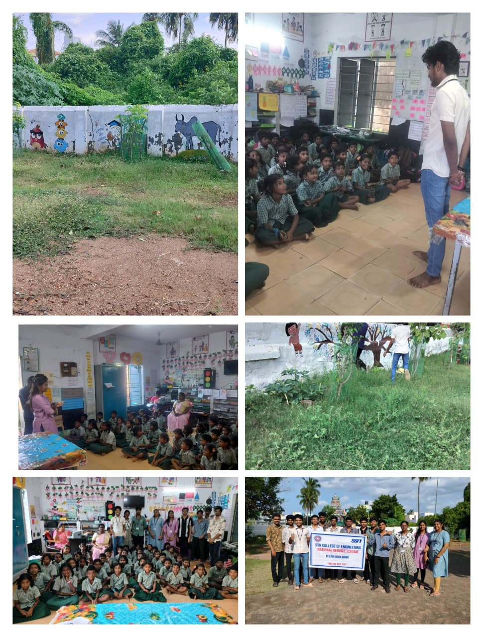
The interaction brought out the enthusiasm of the students, who actively participated in the sessions. NSS volunteers also assessed the school’s needs and condition to identify areas where future efforts can be focused.
The objective of the visit was to instill a sense of social responsibility and community service among volunteers while motivating the students of the school. This initiative strengthened the values of empathy, leadership, and commitment to service among the participants.
We extend our heartfelt gratitude to the school authorities, students, and NSS volunteers for making this visit impactful. Together, we strive to bring positive change and uphold the spirit of service in society.

